**R for Excel Users: Pivot Tables, VLOOKUPs in R**

*Written by Matt Dancho on February 26, 2020*

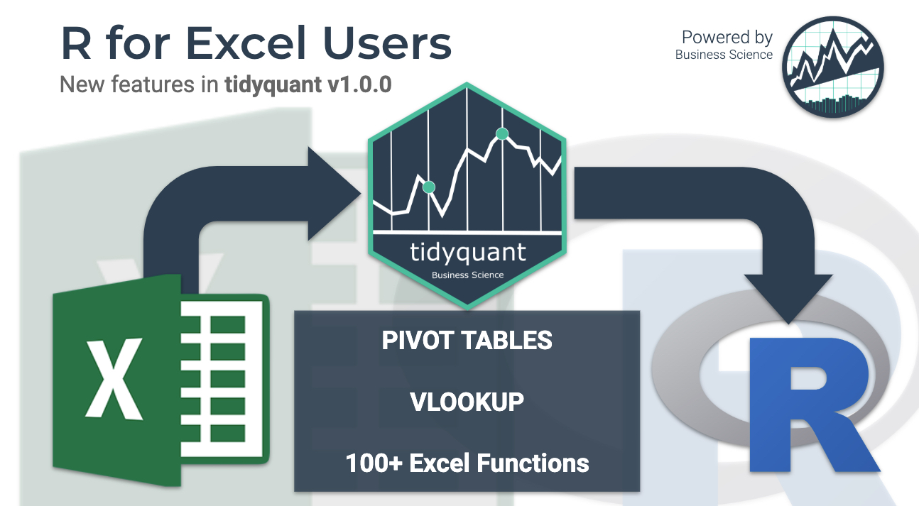

**New business and financial analysts are finding R every day.** Most of these new *userRs* (R users) are coming from a non-programming background. They have ample domain experience in functions like finance, marketing, and business, but their tool of choice is **Excel (or more recently Tableau & PowerBI)**.

**Learning R can be a major hurdle.** You need to learn data structures, algorithms, data science, machine learning, web applications with Shiny and more to be able to accomplish a basic dashboard. This is a *BIG ASK* for non-coders. This is the problem I aim to begin solving with the release of tidyquant v1.0.0. [Read the updated](https://www.business-science.io/finance/2020/02/26/r-for-excel-users.html) *[‘R for Excel Users’](https://www.business-science.io/finance/2020/02/26/r-for-excel-users.html)* [on Business Science](https://www.business-science.io/finance/2020/02/26/r-for-excel-users.html).

Let’s demo several of the new Excel features!

**Articles in Series**

* [Excel to R, Part 1 - The 10X Productivity Boost](https://www.business-science.io/business/2019/02/20/excel-to-r-part-1.html)
* [Excel to R, Part 2 - Speed Up Exploratory Data Analysis 100X](https://www.business-science.io/business/2019/07/08/excel-to-r-part-2.html)
* **[Excel to R, Part 3 - NEW Pivot Tables, VLOOKUPS in R!](https://www.business-science.io/finance/2020/02/26/r-for-excel-users.html)** **(You’re here)**

**Excel in R: Introducing tidyquant 1.0.0  
Pivot Tables, VLOOKUPs, Sum-Ifs, and more**

[](https://www.business-science.io/finance/2020/02/26/r-for-excel-users.html)

In tidyquant version 1.0.0, I have added the following features to **support new *useRs* transitioning from an Excel background.**

**New Features   
To make the transition to R easier for Excel Users**

✅ **[Pivot Tables in R](https://www.business-science.io/finance/2020/02/26/r-for-excel-users.html" \l "pivot-tables)**

✅ **[VLOOKUP in R](https://www.business-science.io/finance/2020/02/26/r-for-excel-users.html" \l "vlookup)**

✅ **[Summarizing “IFS” Functions](https://www.business-science.io/finance/2020/02/26/r-for-excel-users.html" \l "sum-ifs)**

✅ **[100 + New Excel Functions](https://www.business-science.io/finance/2020/02/26/r-for-excel-users.html" \l "excel-functions)**

✅ **[NEW API Integrations (Implementation scheduled for March)](https://www.business-science.io/finance/2020/02/26/r-for-excel-users.html" \l "api-integrations)**

I’ll showcase a **small portion** of the new features in this post. **[Register Here for new Learning Labs (Free)](https://bit.ly/learning_labs)** - I go through real business examples where I showcase packages like using Shiny and tidyquant together (did this in Learning Lab 30).

**Our program is different. We've helped 1000+ students like you.**

**Expert-level Machine Learning skills** and **Predictive Web Application skills**,  
**No experience required!**



**Finding it Difficult to Connect Data Science to Business?**

Shiny App with Pivot Table using tidyquant   
[Register for New Learning Labs Here](https://bit.ly/learning_labs)

**Replication Requirements**

Please use tidyquant (>= 1.0.0), which is now available on CRAN.

# devtools::install_github("business-science/tidyquant")

install.packages("tidyquant")

Load the following libraries.

library(tidyverse)

library(tidyquant)

library(knitr)

**✅ Pivot Tables**

**The Pivot Table is one of Excel’s most powerful features.** Honestly, when I came to R, one of the biggest things I lost was the *Pivot Table* - A tool used for quickly summarizing data into a digestable table. It’s now in R with pivot_table().

**Excel Pivot Table**

For those that may have never used the **Excel Pivot Table** before, the process goes something like this.

1. Start with a raw table in “long” format where each row is a unique observation
2. Use the Excel Pivot Table dialog to position fields into Columns, Rows, and Summarized Values
3. The Pivot Table is returned with the data summarized into columns and rows

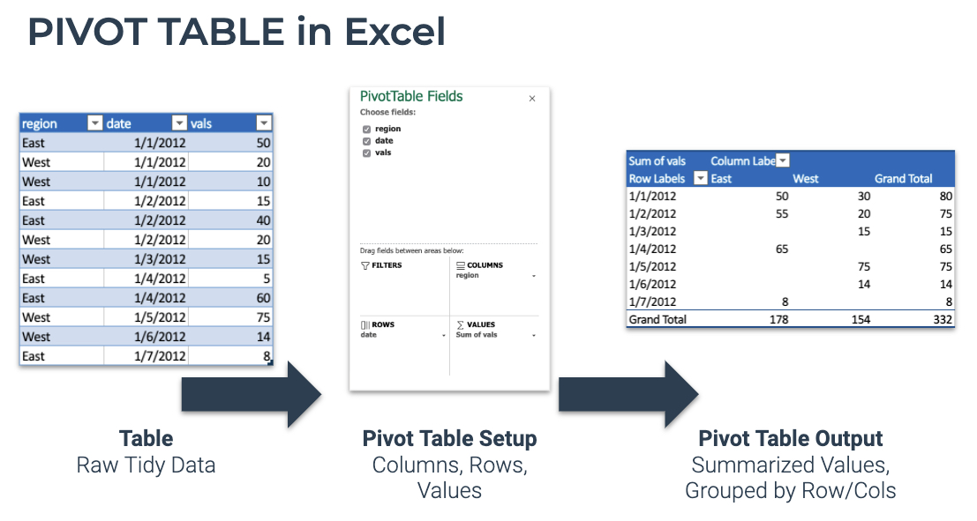

Excel Pivot Table is now in R

**R Pivot Table**

Excel’s Pivot Table now in R with pivot_table(). Let’s try it out.

First, let’s get some raw data. The FANG data set ships with tidyquant and represents the ouput of the tq_get(c("FB", "AMZN", "NFLX", "GOOG")) from 2013 to 2016. This is raw OHLCV data with adjusted stock prices downloaded from Yahoo Finance.

FANG

## # A tibble: 4,032 x 8

## symbol date open high low close volume adjusted

## <chr> <date> <dbl> <dbl> <dbl> <dbl> <dbl> <dbl>

## 1 FB 2013-01-02 27.4 28.2 27.4 28 69846400 28

## 2 FB 2013-01-03 27.9 28.5 27.6 27.8 63140600 27.8

## 3 FB 2013-01-04 28.0 28.9 27.8 28.8 72715400 28.8

## 4 FB 2013-01-07 28.7 29.8 28.6 29.4 83781800 29.4

## 5 FB 2013-01-08 29.5 29.6 28.9 29.1 45871300 29.1

## 6 FB 2013-01-09 29.7 30.6 29.5 30.6 104787700 30.6

## 7 FB 2013-01-10 30.6 31.5 30.3 31.3 95316400 31.3

## 8 FB 2013-01-11 31.3 32.0 31.1 31.7 89598000 31.7

## 9 FB 2013-01-14 32.1 32.2 30.6 31.0 98892800 31.0

## 10 FB 2013-01-15 30.6 31.7 29.9 30.1 173242600 30.1

## # … with 4,022 more rows

We can summarize this information with a Pivot Table using pivot_table(.rows, .columns, .values). First, I’ll take a look to see if there are any missing (NA) values. The only trick is to use a ~ in front of any calculations. All zeros is good.

FANG %>%

pivot_table(

.columns = symbol,

.values = ~ SUM(is.na(adjusted))

) %>%

kable()

| **AMZN** | **FB** | **GOOG** | **NFLX** |
| --- | --- | --- | --- |
| 0 | 0 | 0 | 0 |

Next, I’ll do some financial summarizations. I’d like to take a look at percentage returns by year and quarter. This is easy to do by using stacked functions with the c() operator on .columns and .rows.

FANG %>%

pivot_table(

.rows = c(symbol, ~ QUARTER(date)),

.columns = ~ YEAR(date),

.values = ~ (LAST(adjusted) - FIRST(adjusted)) / FIRST(adjusted)

) %>%

kable()

| **symbol** | **QUARTER(date)** | **2013** | **2014** | **2015** | **2016** |
| --- | --- | --- | --- | --- | --- |
| AMZN | 1 | 0.0356768 | -0.1547856 | 0.2060807 | -0.0680544 |
| AMZN | 2 | 0.0614656 | -0.0530919 | 0.1723923 | 0.1956892 |
| AMZN | 3 | 0.1082595 | -0.0299348 | 0.1703285 | 0.1538281 |
| AMZN | 4 | 0.2425300 | -0.0223965 | 0.2979913 | -0.1038196 |
| FB | 1 | -0.0864286 | 0.1010785 | 0.0480561 | 0.1162199 |
| FB | 2 | -0.0254603 | 0.0745768 | 0.0502020 | -0.0153369 |
| FB | 3 | 1.0245869 | 0.1613283 | 0.0344034 | 0.1233033 |
| FB | 4 | 0.0838954 | 0.0192031 | 0.1507422 | -0.1065466 |
| GOOG | 1 | 0.0980851 | 0.0017401 | 0.0441873 | 0.0041923 |
| GOOG | 2 | 0.0988279 | 0.0143170 | -0.0406450 | -0.0770892 |
| GOOG | 3 | -0.0134815 | -0.0091132 | 0.1659128 | 0.1116688 |
| GOOG | 4 | 0.2634837 | -0.0736798 | 0.2414403 | -0.0009578 |
| NFLX | 1 | 1.0571677 | -0.0297393 | 0.1941594 | -0.0702983 |
| NFLX | 2 | 0.1571014 | 0.2081494 | 0.5901917 | -0.1345316 |
| NFLX | 3 | 0.3786783 | -0.0463327 | 0.1027844 | 0.0194477 |
| NFLX | 4 | 0.1341568 | -0.2214904 | 0.0792602 | 0.2062750 |

A few points:

1. **Collapsing** - I just used functions to collapse the daily date by YEAR() and QUARTER(). This essentially creates a new grouping variable that is a part of the date.
2. **Stacking** - I *stacked* multiple grouping operations with the c() operator: .rows = c(symbol, ~ QUARTER(date))
3. **Summarization Details** - I added multiple function calls to get the Percentage Change in the .values summarization operation. This is allowed as long as the result returns a single value.
4. **Tilde Required** - For calculations (e.g. ~ YEAR(date)), I used the tilde (~) each time, which **is required.**
5. **Tilde Not Required** - For bare column names with no calculation, a tilde (~) is **not required.**

**My Favorite Part of Pivot Tables in R**

**We can easily switch Pivot Tables to provide different levels of summarization.** Now I’ll quickly change to returns by year. Notice I’m using a new summarization function, PCT_CHANGE_FIRSTLAST() to save me some typing.

FANG %>%

pivot_table(

.rows = symbol,

.columns = ~ YEAR(date),

.values = ~ PCT_CHANGE_FIRSTLAST(adjusted)

) %>%

kable()

| **symbol** | **2013** | **2014** | **2015** | **2016** |
| --- | --- | --- | --- | --- |
| AMZN | 0.5498426 | -0.2201673 | 1.1907495 | 0.1772084 |
| FB | 0.9517858 | 0.4260647 | 0.3340983 | 0.1255136 |
| GOOG | 0.5495473 | -0.0532416 | 0.4460024 | 0.0404130 |
| NFLX | 3.0014129 | -0.0584587 | 1.2945491 | 0.1258640 |

**✅ VLOOKUP**

**When I first started learning R, I couldn’t grasp how to merge / join data.** It was very frustrating because I was used to Excel’s VLOOKUP function that pulled a value or a column of values as needed.

**Excel VLOOKUP**

VLOOKUP is an Excel function to lookup and retrieve data from a specific column in table. Here’s how the process works in Excel.

1. Start with a Lookup Table. Contains Key-Value pairs.
2. Simple Case - Use a VLOOKUP to input a single value and output a single value.
3. More Powerful Case - Use a VLOOKUP to add a column to an Excel Table.

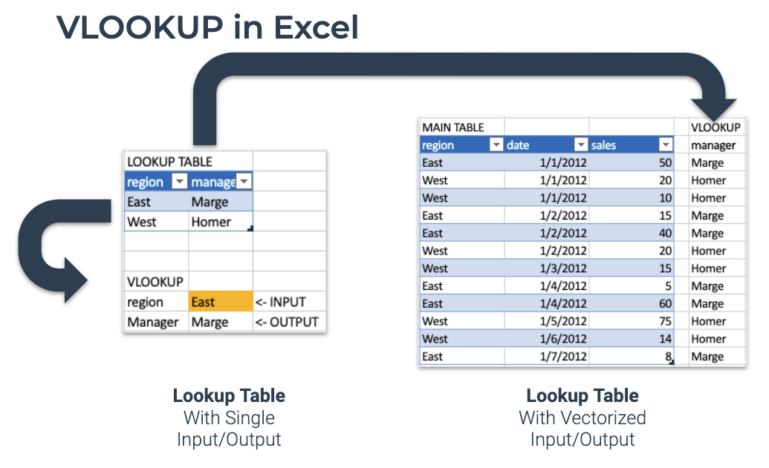

Excel VLOOKUP() is now in R

**R VLOOKUP**

The most popular Excel Reference Function, VLOOKUP, is now in R as VLOOKUP(). It’s vectorized, which means we can use VLOOKUP() inside of dplyr::mutate().

Let’s replicate a VLOOKUP in R using the new VLOOKUP() function. First, let’s create a simple lookup table.

lookup_table <- tibble(

stock = c("FB", "AMZN", "NFLX", "GOOG"),

company = c("Facebook", "Amazon", "Netflix", "Google")

)

lookup_table %>% kable()

| **stock** | **company** |
| --- | --- |
| FB | Facebook |
| AMZN | Amazon |
| NFLX | Netflix |
| GOOG | Google |

**Simple VLOOKUP Case**

First, let’s mimic the “simple” case where we just want to lookup a **Single Value.**

VLOOKUP("AMZN", lookup_table, stock, company)

## [1] "Amazon"

So what happened? We supplied the string “AMZN”, and the VLOOKUP() function new to search the lookup_table matching the stock column and returning the company.

**More Powerful VLOOKUP Case**

Let’s try the more **Powerful Case** - pulling in a column of matched lookup values. We can do this by using the mutate() function from dplyr. This works because VLOOKUP() is vectorized.

FANG %>%

mutate(company = VLOOKUP(symbol, lookup_table, stock, company))

## # A tibble: 4,032 x 9

## symbol date open high low close volume adjusted company

## <chr> <date> <dbl> <dbl> <dbl> <dbl> <dbl> <dbl> <chr>

## 1 FB 2013-01-02 27.4 28.2 27.4 28 69846400 28 Facebook

## 2 FB 2013-01-03 27.9 28.5 27.6 27.8 63140600 27.8 Facebook

## 3 FB 2013-01-04 28.0 28.9 27.8 28.8 72715400 28.8 Facebook

## 4 FB 2013-01-07 28.7 29.8 28.6 29.4 83781800 29.4 Facebook

## 5 FB 2013-01-08 29.5 29.6 28.9 29.1 45871300 29.1 Facebook

## 6 FB 2013-01-09 29.7 30.6 29.5 30.6 104787700 30.6 Facebook

## 7 FB 2013-01-10 30.6 31.5 30.3 31.3 95316400 31.3 Facebook

## 8 FB 2013-01-11 31.3 32.0 31.1 31.7 89598000 31.7 Facebook

## 9 FB 2013-01-14 32.1 32.2 30.6 31.0 98892800 31.0 Facebook

## 10 FB 2013-01-15 30.6 31.7 29.9 30.1 173242600 30.1 Facebook

## # … with 4,022 more rows

**What I’m Most Excited About Using VLOOKUP for**

I actually can’t wait to use VLOOKUP() in Shiny apps. There are many times when I want the user to input a variable (a Key), and internally on the Shiny Server convert it to something more useful in a table (a Value). I showcased this technique LIVE in Learning Lab 30 - Shiny + Tidyquant Apps. [Register Here to attend new Learning Labs (FREE)](https://bit.ly/learning_labs).

**✅ Summarizing “IFS” Functions**

One of the functions that many Excel Users (including myself) become accustomed to is **filtering summations, which I refer to as “IFS” functions.** These are very handy at quickly filtering on conditions while aggregating your data.

**Excel Sum-If’s (and friends)**

Excel has SUMIFS(), COUNTIFS(), AVERAGEIFS(), and several more Summarizing “IFS” Functions. Here’s how they work:

1. Develop a Condition to summarize: Sum Sales when Region = “East”
2. Use one or more Conditioning Column(s) to develop a logical cases (e.g. region = “East”)
3. Use a Summarizing Column to aggregate (e.g. SUMIFS(sales))
4. Put it together returning a single value: SUMIFS(sales, region, “=East”)

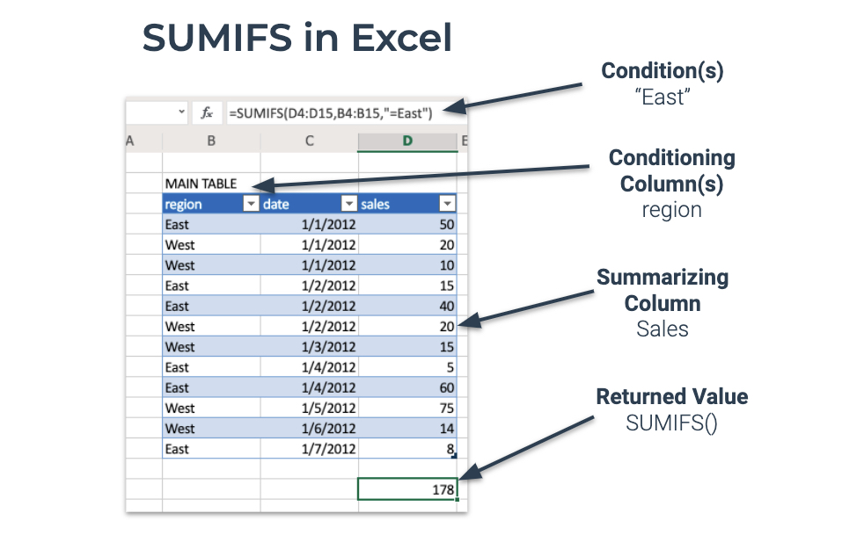

Excel SUMIFS is now in R as SUM_IFS()

**R Sum-If’s (and friends)**

**R now has a full suite of “IFS” functions.** We can test them to get the basics.

**SUM_IFS()**

Summarizing things.

SUM_IFS(x = 1:10, x > 5)

## [1] 40

**COUNT_IFS()**

Counting things.

COUNT_IFS(x = letters, str_detect(x, "[a-c]"))

## [1] 3

**Used in tidyverse**

Let’s use COUNT_IFS() to count how many times high trade volume occurs in 2015. We can accomplish this shockingly easily by combining summarise() and the COUNT_IFS() function.

FANG %>%

group_by(symbol) %>%

summarise(

high_volume_in_2015 = COUNT_IFS(volume,

year(date) == 2015,

volume > quantile(volume, 0.75))

)

## # A tibble: 4 x 2

## symbol high_volume_in_2015

## <chr> <int>

## 1 AMZN 62

## 2 FB 15

## 3 GOOG 19

## 4 NFLX 54

**✅ 100+ New Excel Functions**